Tool: R Programming Register No: 192424189
Name: Dhanusha D Date: 10-07-2026
Subject: Data Handling & Visualization Code:DSA0604

Scenario 1: Student Academic Performance Dashboard
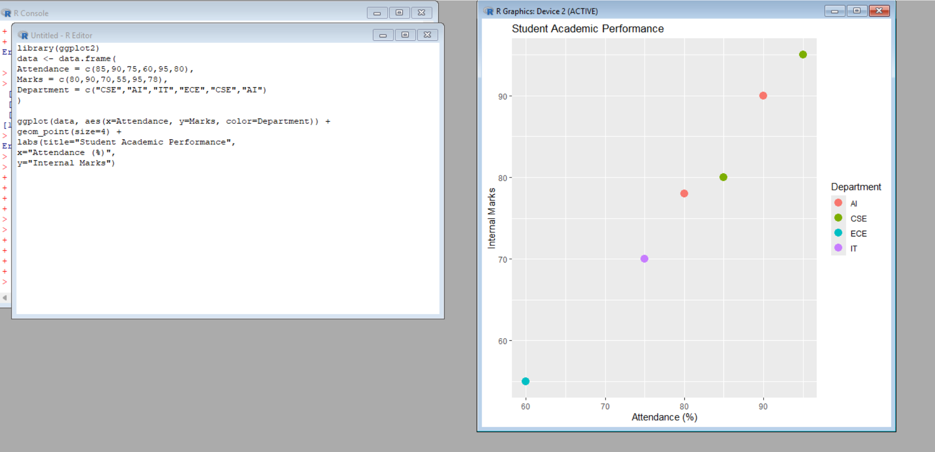

Scenario 2: Electric Vehicle Market Analysis
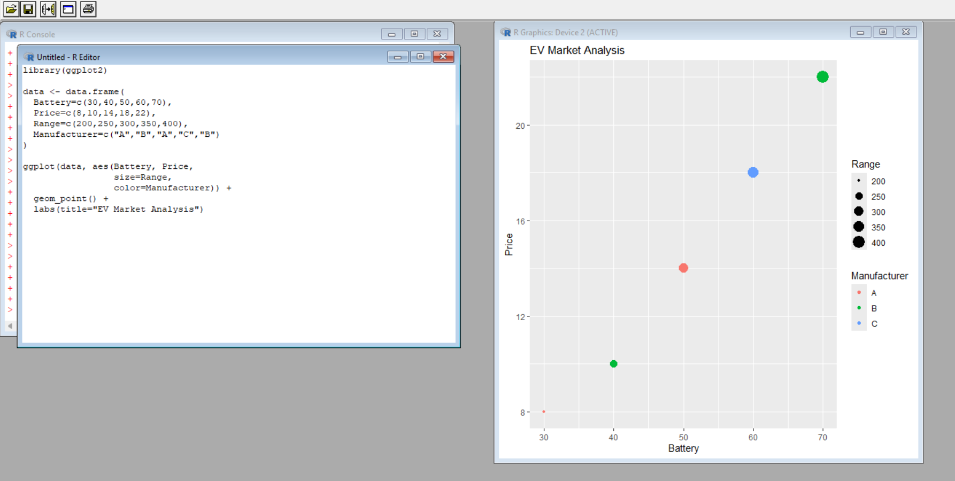

Scenario 3: Hospital Patient Admission Analysis
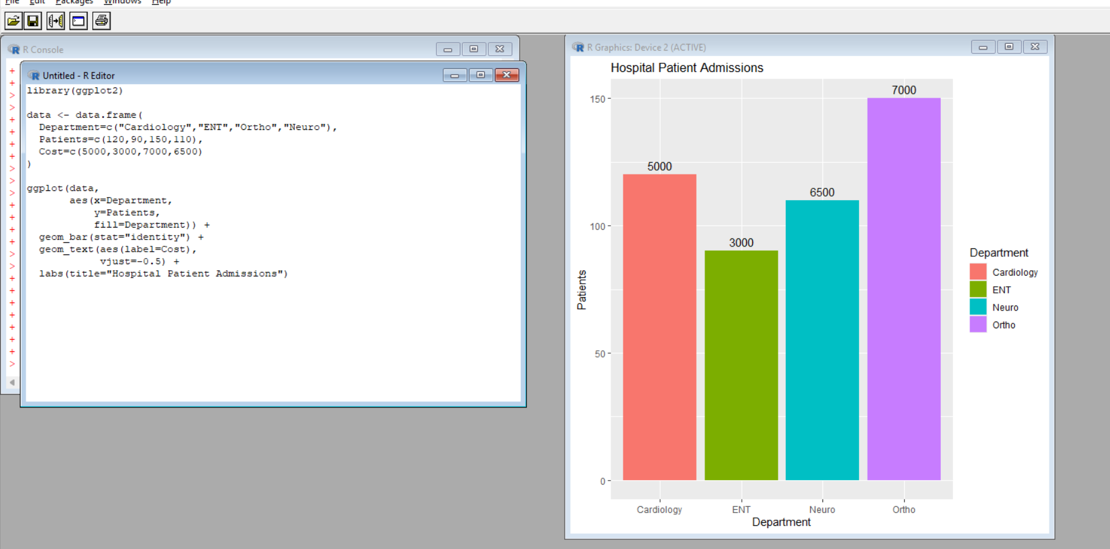

Scenario 4: Weather Monitoring System
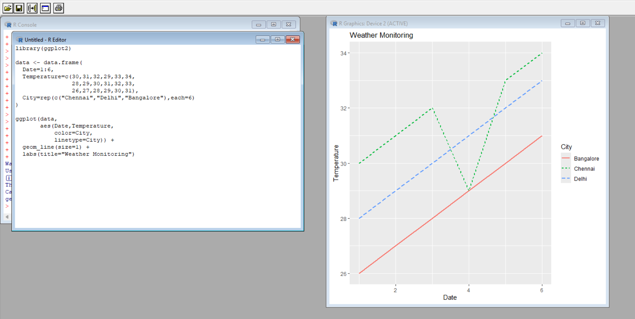

Scenario 5: Supermarket Sales Analysis
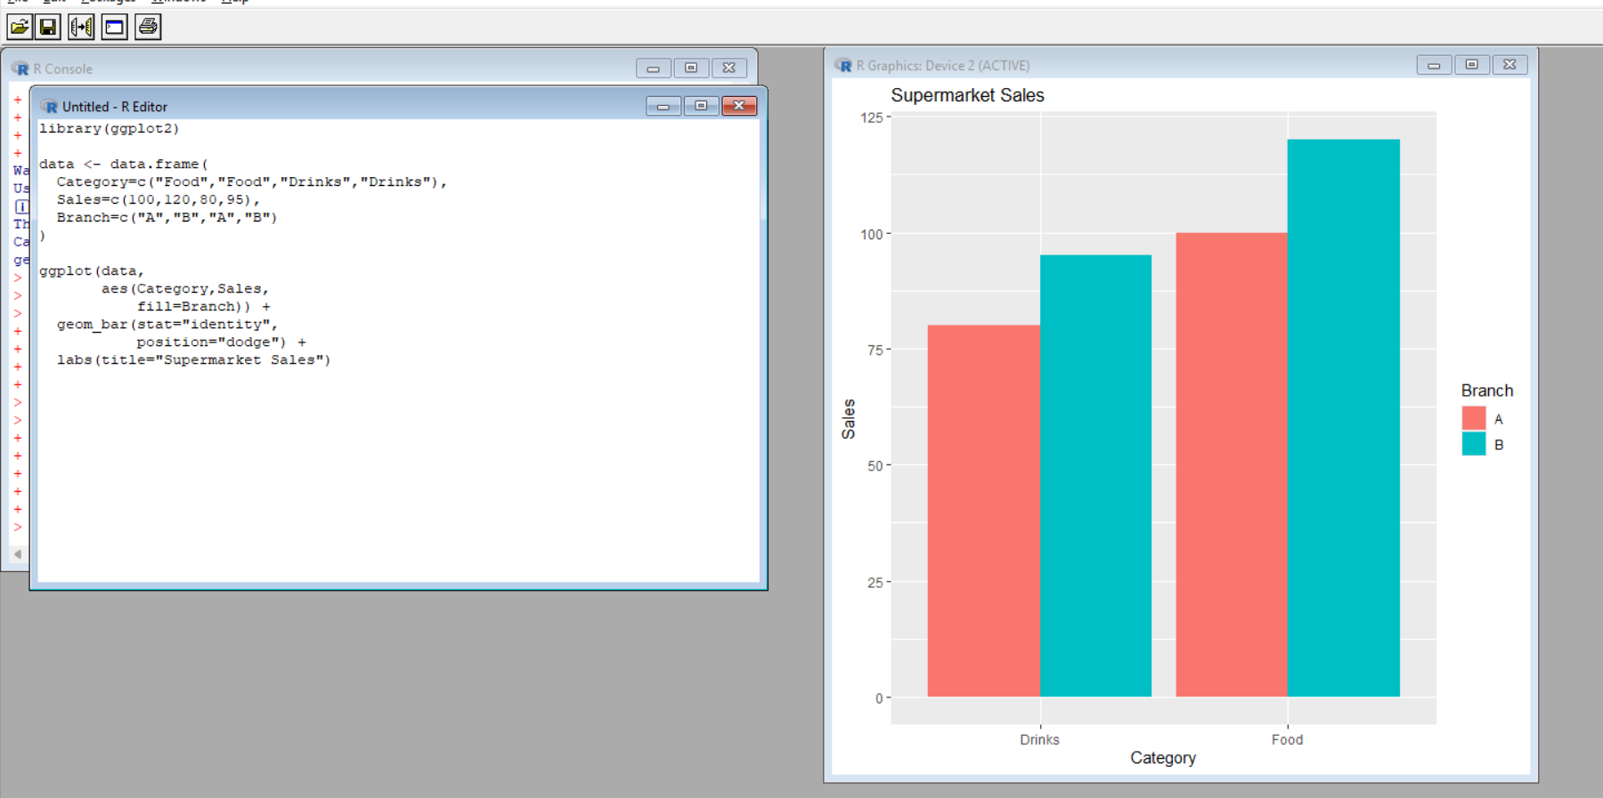

Scenario 6: Employee Salary Distribution
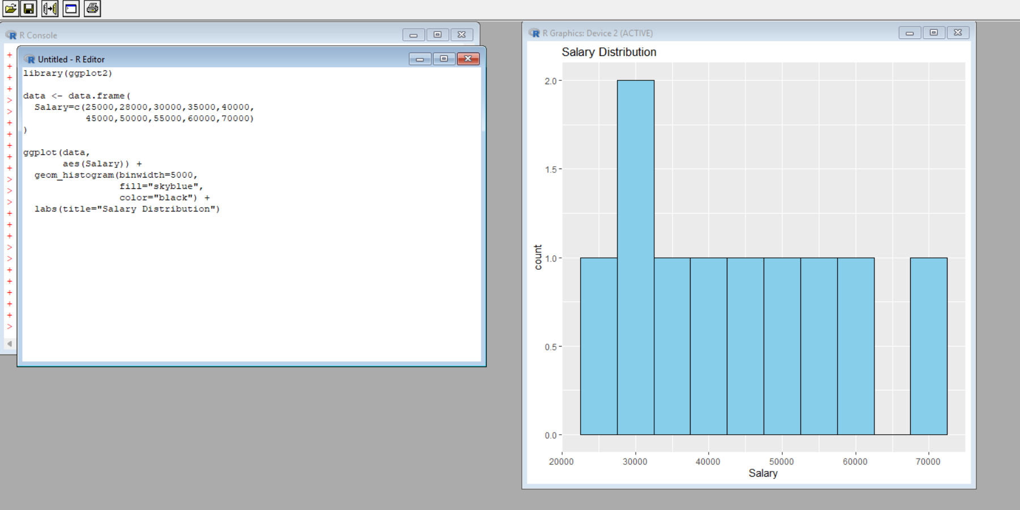

Scenario 7: Smartphone Market Comparison
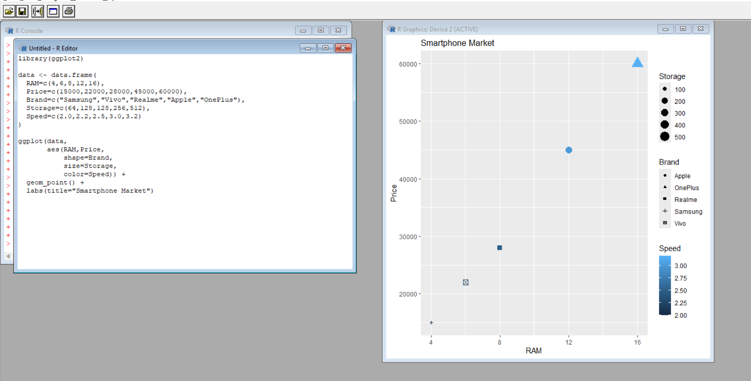

Scenario 8: Online Movie Rating Analysis
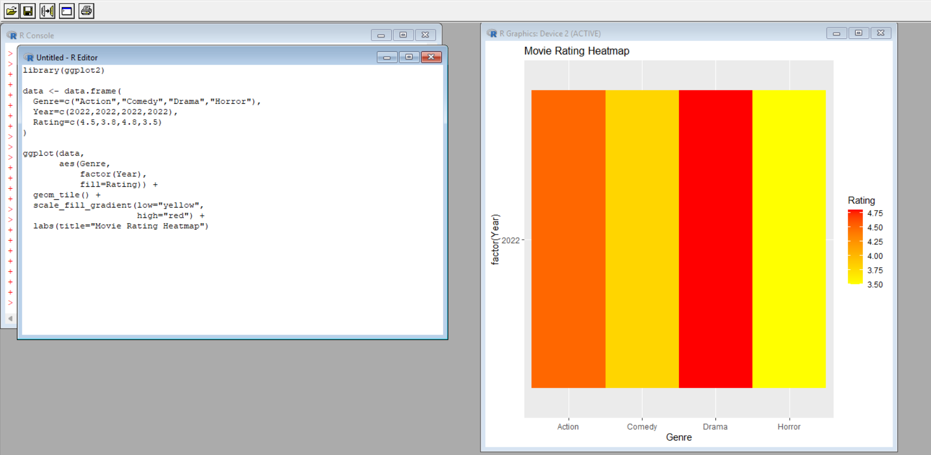

Scenario 9: COVID-19 State-wise Analysis
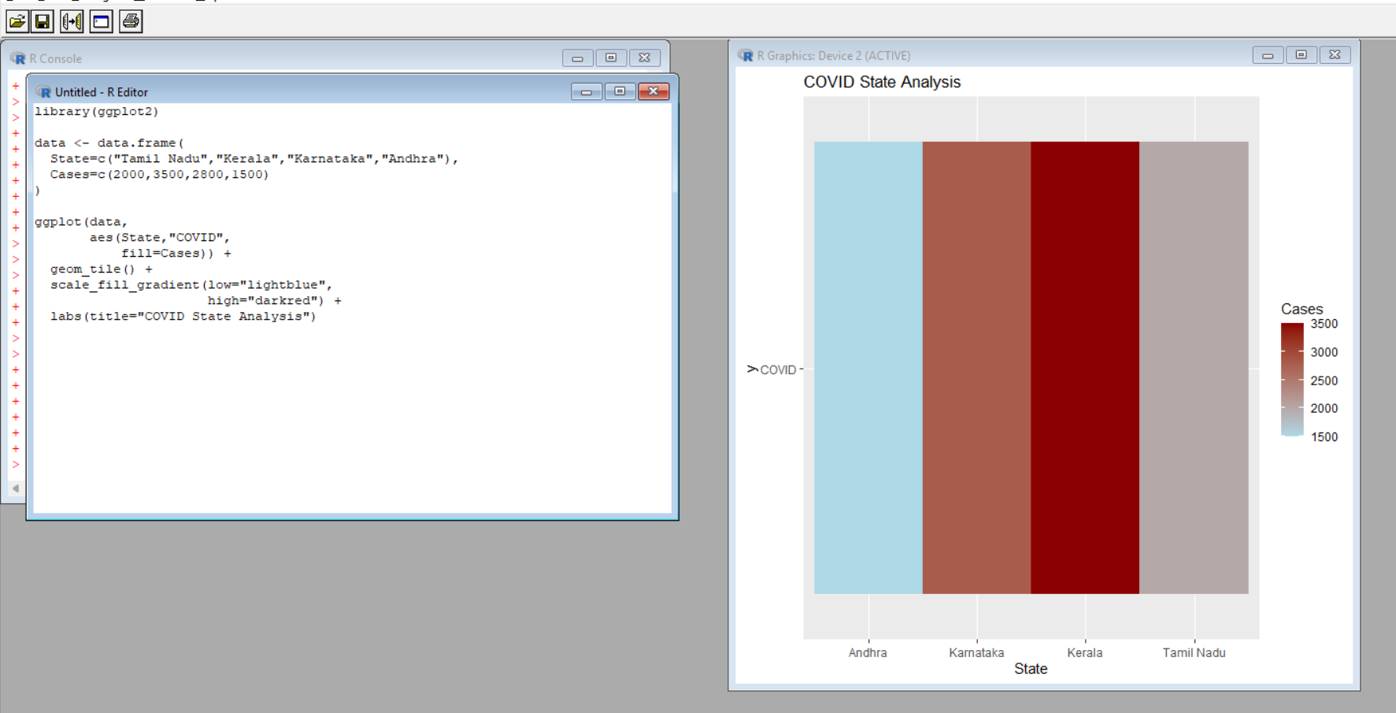

Scenario 10: Iris Flower Classification
